 | Monday | Tuesday | Wednesday | Thursday | Friday
Have you washed, dressed yourself, brushed your hair, made your bed and brushed your teeth today?
We always start our day with our prayers. Have a lovely day. We are thinking about each and every one of you. xx
Approximately  15 – 30 mins | Well-Being  Let the Music Move your Feet Movement & Dance Song for Kids | Debbie Doo – Balance on one foot  https://www.youtube.com/watch?v=aQ2Vco_giiE | Well-Being  Let the Music Move your feet Movement & Dance Song for Kids | Debbie Doo – Balance  on one foot  https://www.youtube.com/watch?v=aQ2Vco_giiE | Well-Being  5-a-day Fitness: All Sports Routine – Jubilee Dance  https://www.youtube.com/watch?v=gBTvnJpwcKw | Well-Being  5-a-day Fitness: All Sports Routine - Jubilee Dance  https://www.youtube.com/watch?v=gBTvnJpwcKw | Well Being  Have a laugh!  https://www.youtube.com/watch?v=KnC6t59FXcs
Topic Work | Watch Peppa Pig  We Love Peppa Pig The Castle #1 - Bing video.  Talking time  Why does the knight wear armour?  Where was the secret passage?  Where did the secret passage lead?  Why was the food not real?  What was the dragon made out of?  What other things did Peppa Pig’s family do on the tour? | Barnaby Bear visits a castle  https://www.bbc.co.uk/programmes/p01159k0  Find out more about castles.  Can you find out what 5 of these are?  - The Keep.  - Moat. ...  - Drawbridge. ...  - Portcullis. ...  - Arrowslits. | How to draw a castle  https://www.youtube.com/watch?v=opXUQ7kOkWs  Does you castle have a  - Drawbridge. ...  - Portcullis. ...  - Arrowslits. | Make a Castle.  Use anything that you can find at home.  This could be Lego, empty boxes, empty tins, blocks, newspaper…..  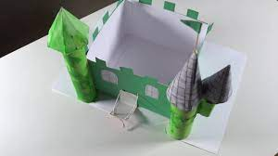
Approximately  15 - 20 mins | Reading  Choose one of your own story books or log into Reading Eggs and choose a book.  We encourage children to look at the pictures in the book they are reading and always ask them to explain their ideas to us by talking in full sentences.  Examples:  - I think this story is about …., because I can see a ….  - Give children a little while to look at the front cover and ask them; What do you think this story might be about? Encourage them to explain their ideas using information they can see from the picture  - Choose a child to point to the title. How do you know that is the title? (it is usually in the biggest writing) and have a go at reading the title  - Choose children to point to words they do know and ask other children to point to any words they do not know.  Encourage a child to explain ‘fiction’ (these are books that tell a ‘made-up’ story. |  |  | Reading  Listen to the story  https://www.youtube.com/watch?v=0MQ5pVeYySU  The Princess and the Wizard | Reading  Listen to the Story  https://www.youtube.com/watch?v=5iOsBset22o  The Worst Princess
Maths White Rose – Summer Activity Week
Approximately  15 - 20 mins | Maths  https://whiterosemaths.com/homelearning/early-years/summer-activity-week/  Session 1  Going on Holiday | Maths  https://whiterosemaths.com/homelearning/early-years/summer-activity-week/  Session 2  Sports Day | Maths  https://whiterosemaths.com/homelearning/early-years/summer-activity-week/  Session 3  At the Beach | Maths  https://whiterosemaths.com/homelearning/early-years/summer-activity-week/  Session 4  Day Trips | Maths  https://whiterosemaths.com/homelearning/early-years/summer-activity-week/  Session 5  Ice Creams
Religious Education
Think about all the friends that you have made in Reception Class. What is the thing that you have enjoyed the most? What have you learned? What else are you thankful for?
Write a prayer to say thank you to God for these things.
What would you like to happen when you are in Year 1. Add this to your prayer.
Additional  Optional  Activities | Join the big Butterfly Count  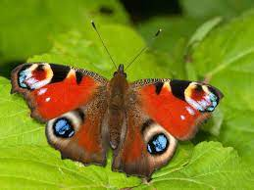  https://bigbutterflycount.butterfly-conservation.org/  https://www.bbcgoodfood.com/howto/guide/guide-cookery-skills-age  The Big Butterfly Count is a UK-wide survey aimed at helping us assess the health of our environment simply by counting the amount and type of butterflies (and some day-flying moths) we see. | Practise tying shoelaces  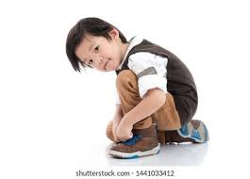  https://www.youtube.com/watch?v=biPlP4yiyQs | Play Dots and Boxes  https://www.youtube.com/watch?v=FLNPAKBJavY  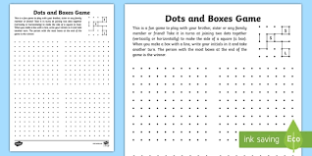 | Make Play Dough  https://theimaginationtree.com/best-ever-no-cook-play-dough-recipe/  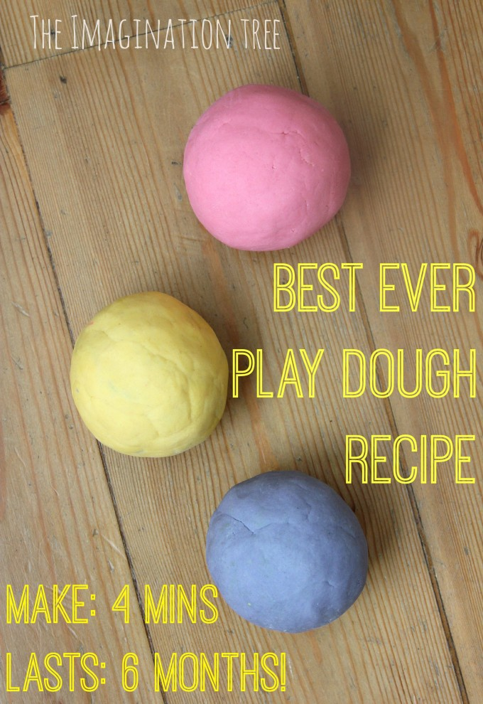 | Enjoy Yourselves!  https://www.youtube.com/watch?v=NsbRIg-ebWg
 | Google Classroom  Times and groups to be emailed by class teachers. | Beat your own Record.  How many Spotty Dogs can you do in 30 seconds? Keep practising every day to see how much faster and stronger you get.  Spotty Dogs  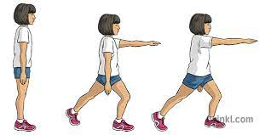  https://www.youtube.com/watch?v=FVh-TXqQBOA | Keep practising Tricky Words  Phase 2  https://www.youtube.com/watch?v=TvMyssfAUx0  Phase 3  https://www.youtube.com/watch?v=R087lYrRpgY  Phase 4  https://www.youtube.com/watch?v=3NOzgR1ANc4  Play one of the games on this page to practise your tricky words and have fun!  https://earlyimpactlearning.com/teach-tricky-words/ | Free National Gallery Online Family Events  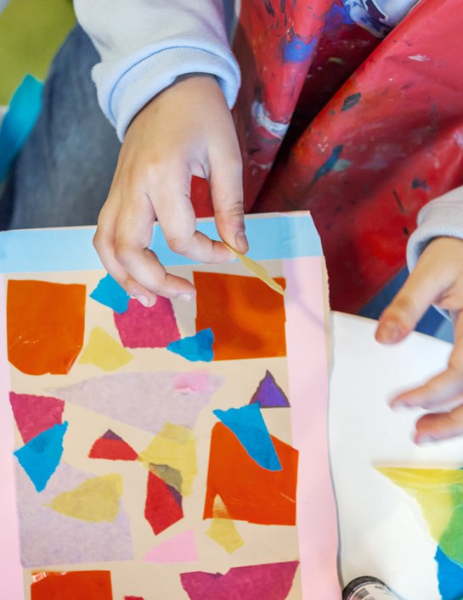  https://www.nationalgallery.org.uk/visiting/visit-as-a-family

